Monitoring tensions and supporting conflict sensitivity in Lebanon
The Tensions Monitoring System works with government, donors, and humanitarian and development partners in Lebanon to monitor tensions and promote the adoption of more conflict sensitive practices. By doing so, we help partners delivering humanitarian and development assistance to avoid doing harm and maximize their contributions to social stability.
On this portal, you can access all tensions monitoring data and reports, as well as conflict sensitivity tools, guidance and training opportunities.
About the Tensions Monitoring System

The Tensions Monitoring System is a project established in 2017 through a collaboration between UNDP, UNHCR, the Ministry of Social Affairs, and the Ministry of Interior and Municipalities in Lebanon. The system regularly collects, analyzes, and disseminates data on tensions and communal relations in Lebanon, with the ultimate objective of supporting partners in developing a better and deeper understanding of tensions and conflict in the country. The system also uses this analysis to provide conflict-sensitive recommendations, guidance, and technical support to UN, NGO, government, and donor partners.
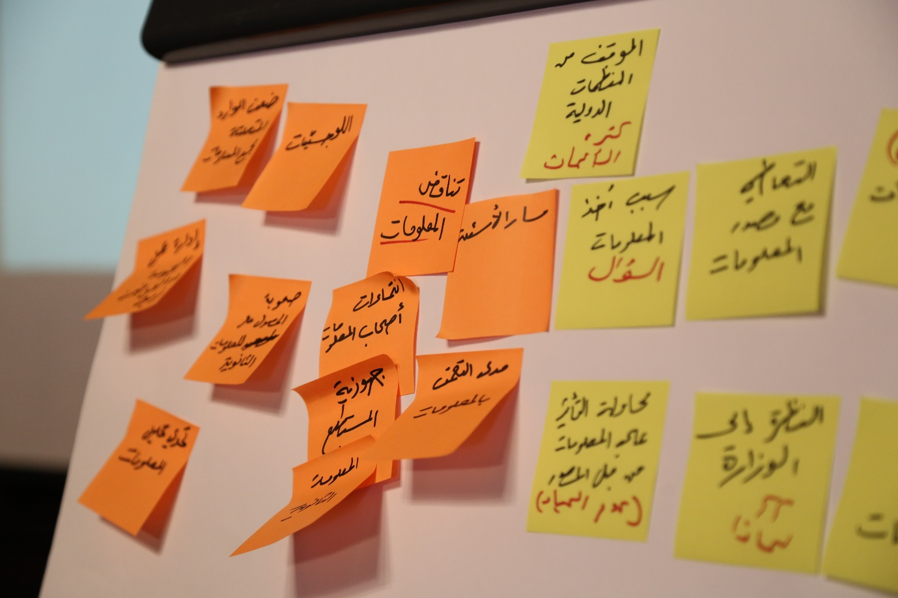
How we collect data
The Tensions Monitoring System utilizes multiple data sources such as:
- Regular Perception Surveys: Together with ARK, we conduct quarterly surveys with around 5,000 individuals, capturing public sentiments. This provides a unique time series data reflecting the evolution of Lebanon’s tensions.
- Field Monitoring & Rapid Conflict Analysis: We regularly bring together Government, UN and NGO partners in each governorate to share insights on tensions and conduct a structured conflict analysis.
- Incident Monitoring: Together with Triangle, we collect and map tensions incidents through open sources and field monitoring.
- Social Media Monitoring: In partnership with Meltwater, we analyze open-source traditional media and social media platforms to understand public discourse and identify online tensions, utilizing innovative technology.
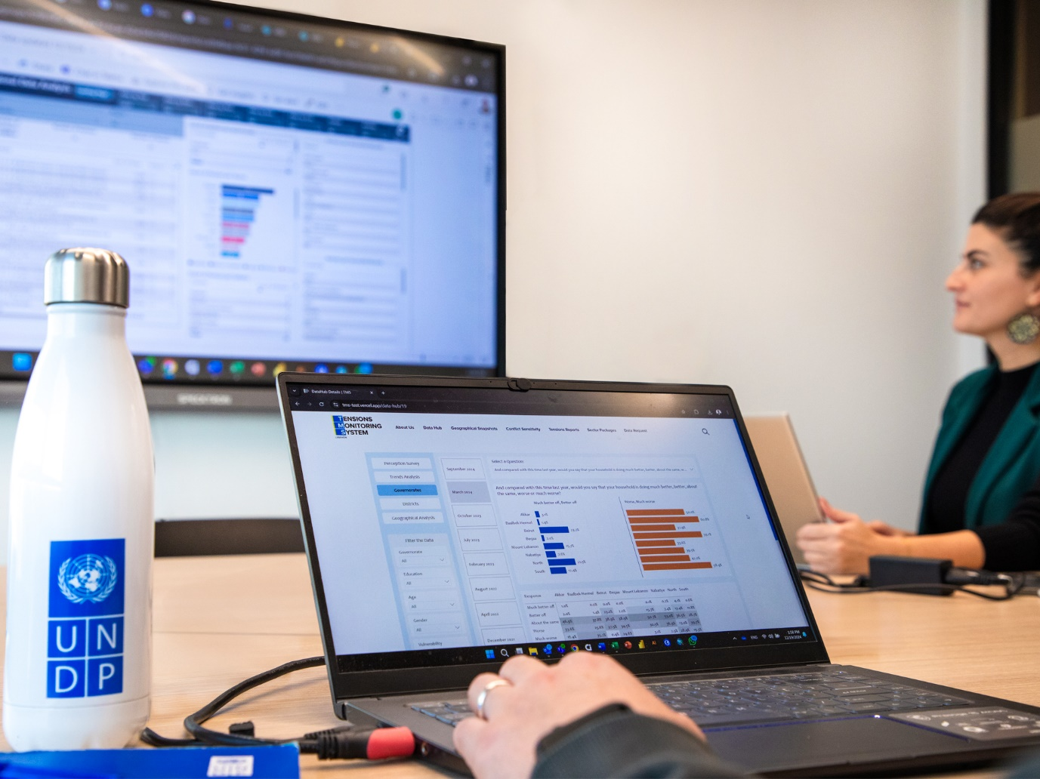
How we analyze data
Once collected, the data undergoes rigorous analysis to identify tensions trends and insights:
- Triangulation: To ensure accuracy, the Tensions Monitoring System cross-verifies findings from multiple sources, strengthening the credibility of the analysis and minimizing biases.
- Trend Identification: By comparing data over time, we can better discern patterns and shifts in communal relations.
- Geographical Mapping: We analyze and compare data geographically to identify hotspots, facilitating targeted interventions in high tensions areas.
- Conflict Analysis: Through a structured examination of underlying tensions drivers and factors, the Tensions Monitoring System enables a deeper understanding of root causes.
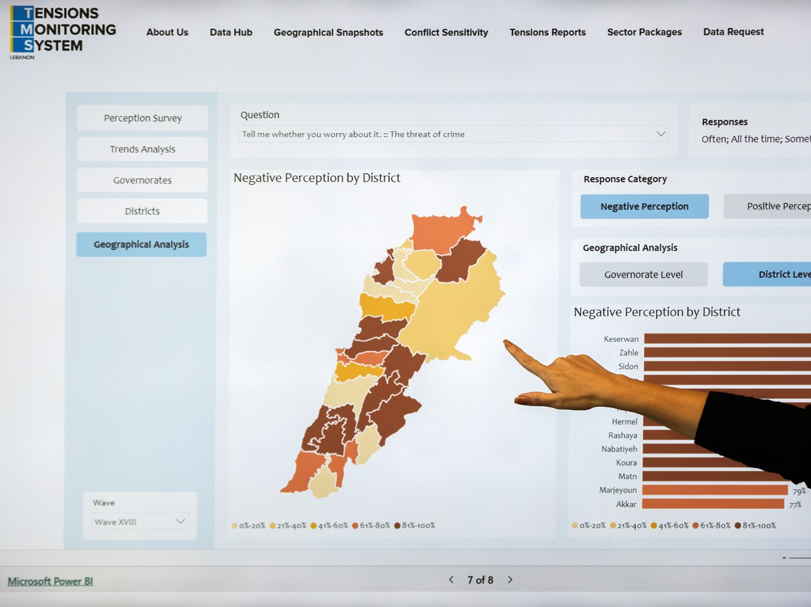
How we disseminate data
The findings from the Tensions Monitoring System are disseminated to a wide range of stakeholders in Lebanon through:
- Regular Reporting: We produce periodic reports which are shared with partners operating under the Lebanon Response Plan (LRP).
- Presentations: Tensions data and analysis are presented in national and regional LRP sector working groups.
- Stakeholder Engagement: Findings are discussed with partners in sector and partner meetings where recommendations are formulated and integrated into response strategies. The Social Stability sector is the main ‘home’ of the Tensions Monitoring System.
- Capacity Building: We offer training and support to partners, enhancing their ability to integrate conflict sensitivity.

